2024 Grafton Flag Football Schedule

Week | Date | 09:00 AM |  | 10:30 AM |  | 12:00 PM
 |  | Away | Home | Away | Home | Away | Home
1 | 09/15 | Ravens | 49ers | Eagles | Chiefs | Seahawks | Lions
2 | 09/22 | Chiefs | Lions | Seahawks | 49ers | Eagles | Ravens
3 | 09/29 | Lions | 49ers | Eagles | Seahawks | Chiefs | Ravens
4 | 10/06 | Ravens | Seahawks | Lions | Eagles | 49ers | Chiefs
5 | 10/13 | Seahawks | Chiefs | Ravens | Lions | 49ers | Eagles
6 | 10/20 | Chiefs | Eagles | 49ers | Ravens | Lions | Seahawks

*Away teams wear the white (or light color) of their jersey. Home wears color (or darker color.)

Playoff Bracket
10/27 – 12:00 PM
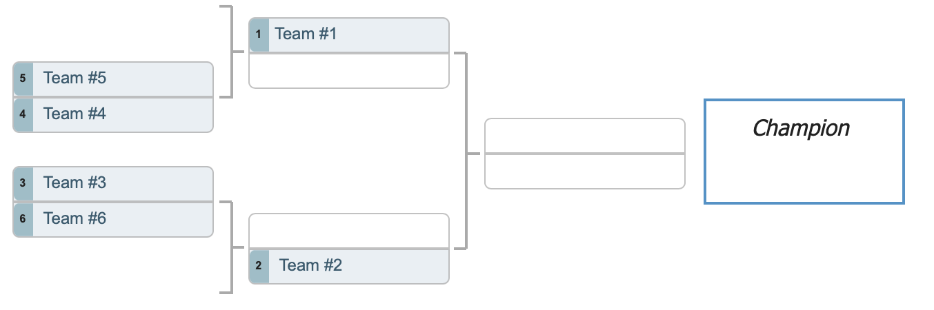
11/03 – 10:30 AM
11/03 – 9:00 AM
10/27 – 10:30 AM
10/27 – 9:00 AM

