Once the registration for a membership is complete, the digital card assigned to it may be accessed through the household account on the Public Side, after logging into the account.

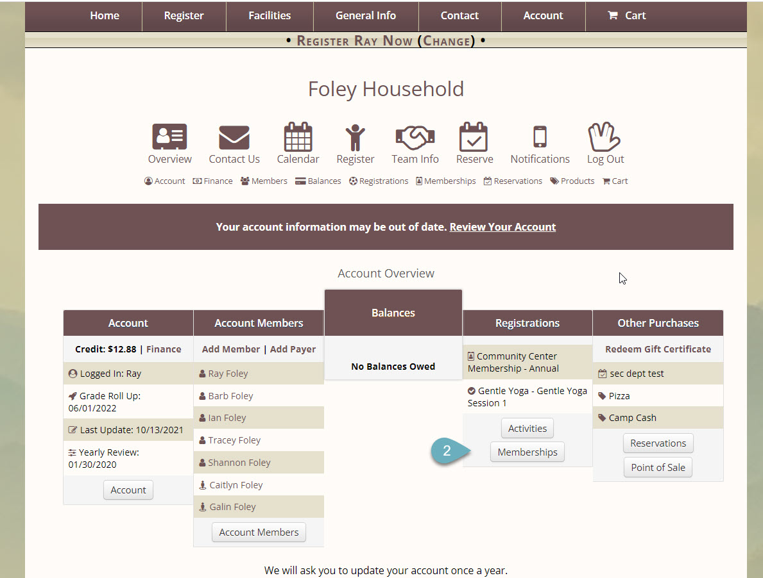

1. Navigate to the Account Overview page
2. Click the **Memberships**tab
3. Select the **View Membership Cards** link, which will be under the associated membership

It may also be accessed through a link on the registration receipt, if the option to Send Cards on Registration is selected.

The card can be saved to the device it is being viewed on by selecting the **Save to Device** button at the top of the image. It will be saved as a PNG file.